Harvest Haven 18th Anniversary Conference

Scott Countryman (Speaker)
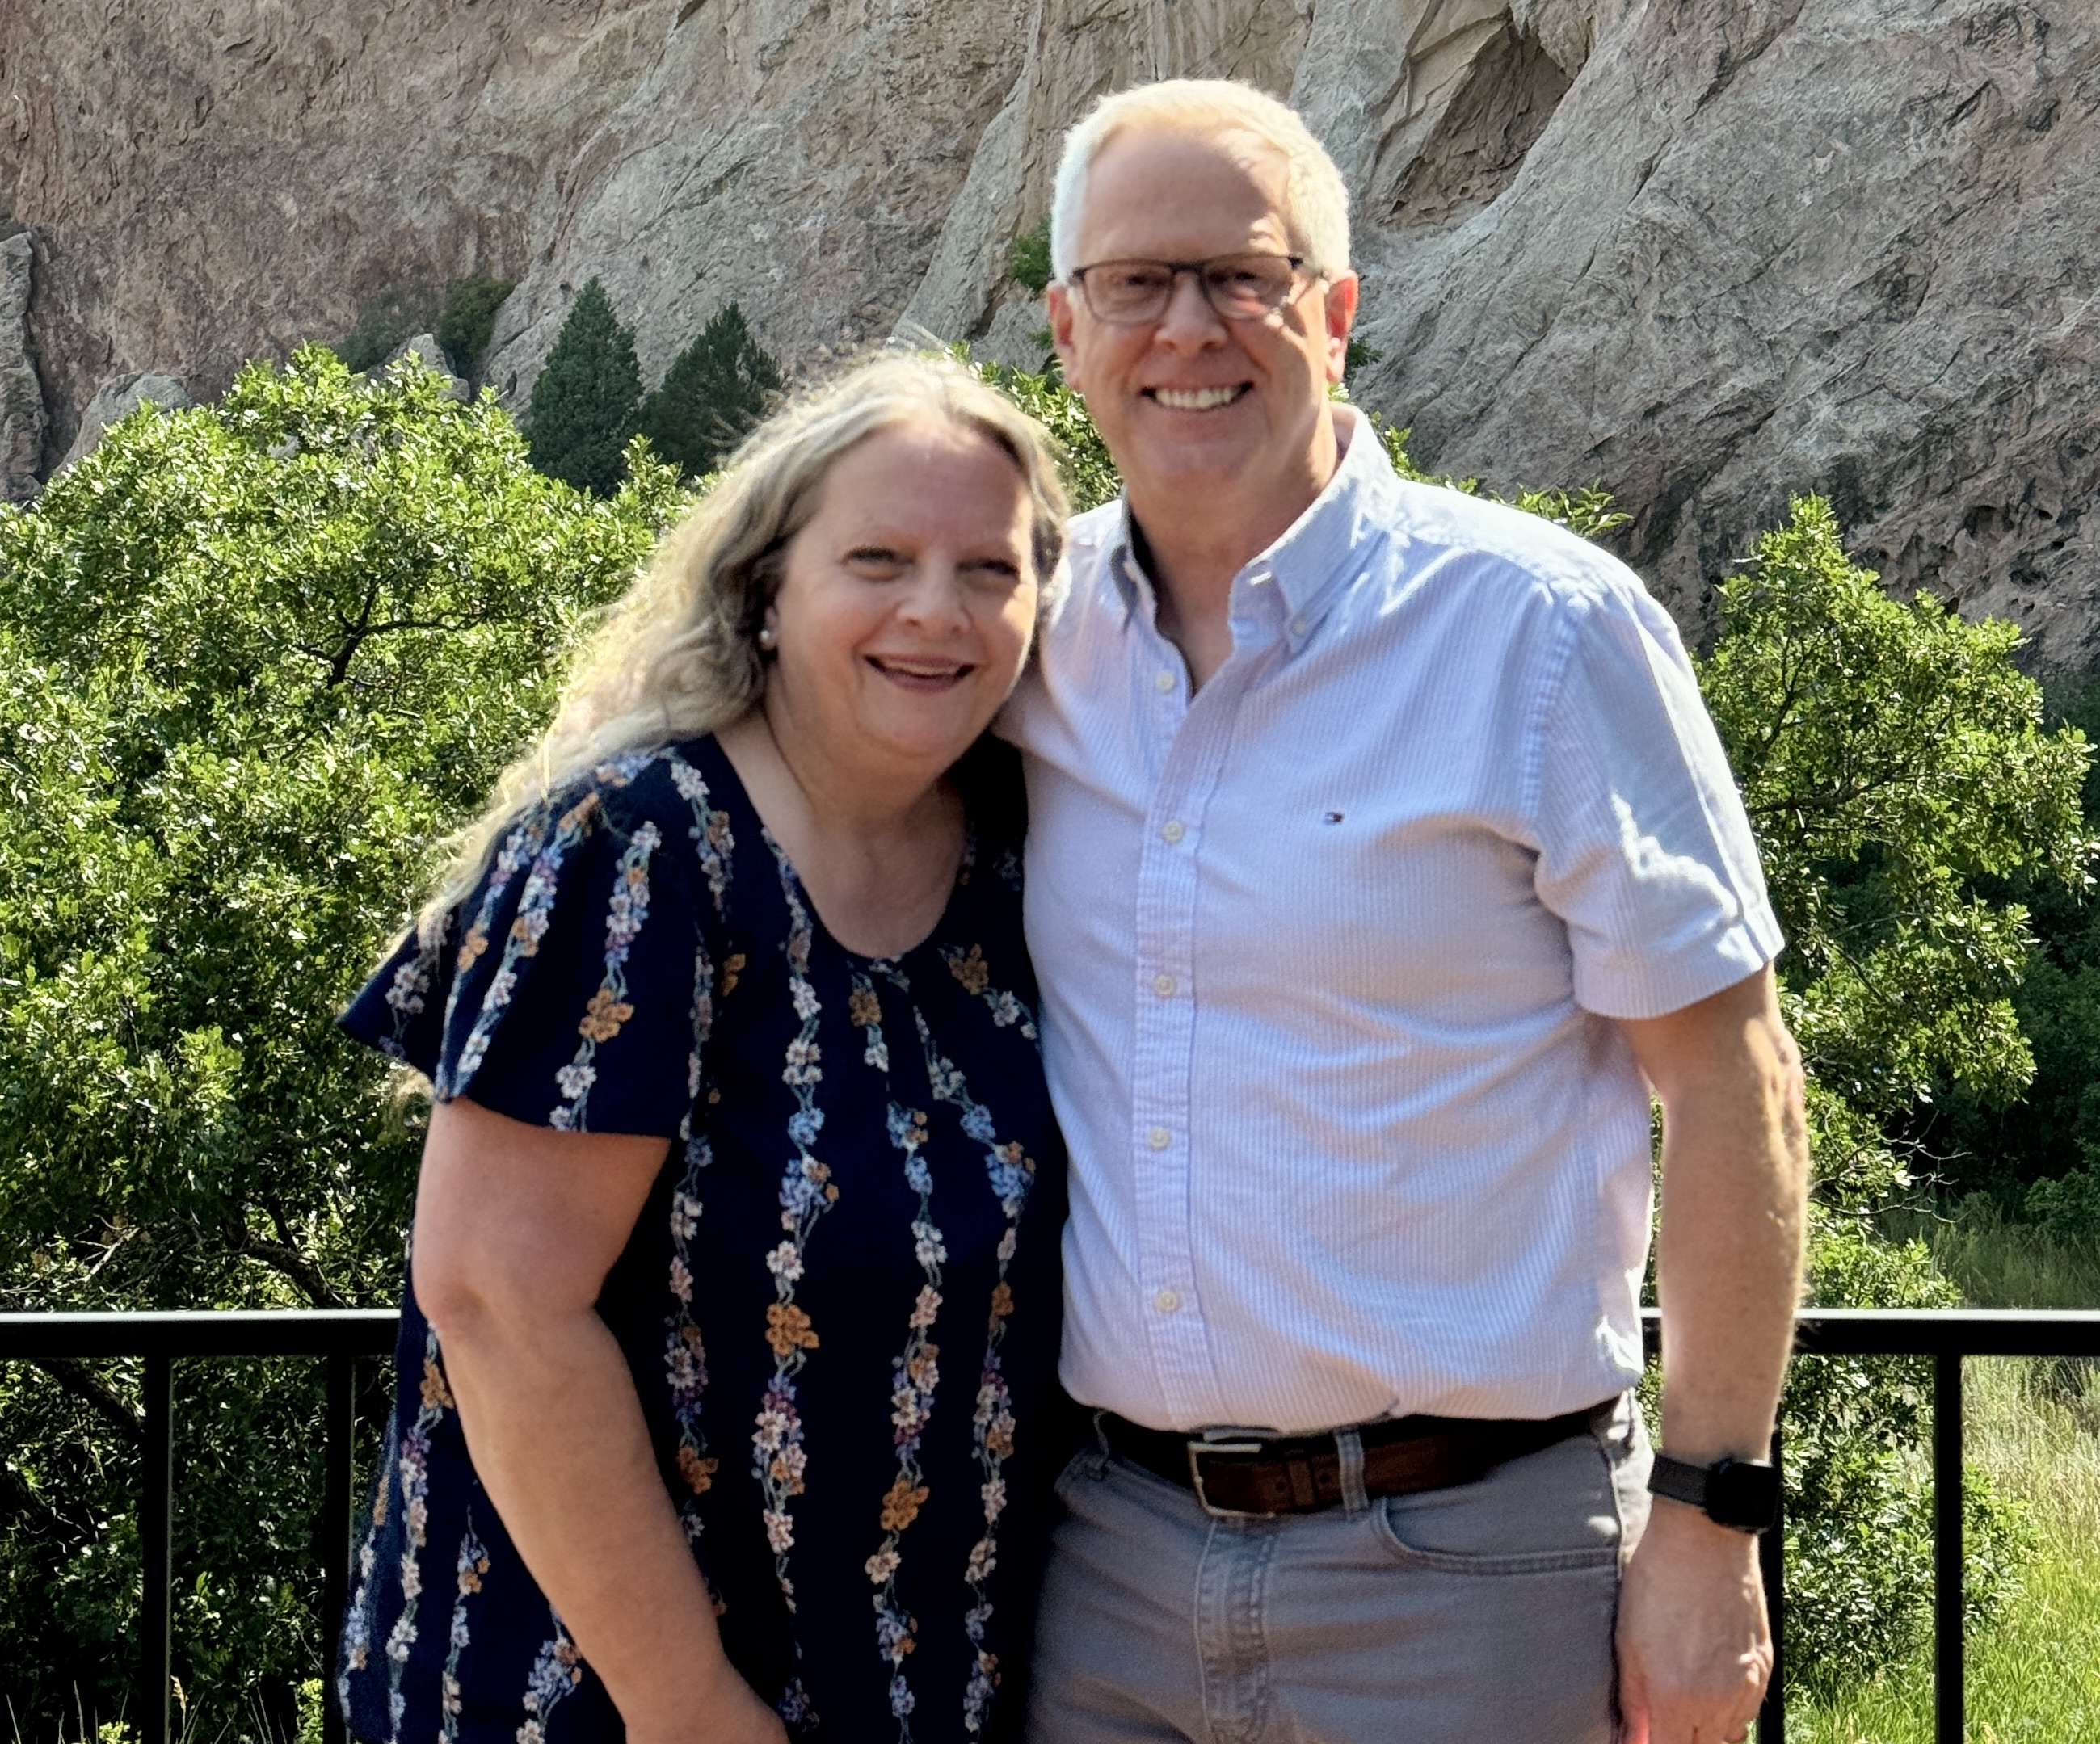
Serving with Global Training Network
Scott is a missionary with Global Training Network, where he serves as the Executive Director of Resource Development. His ministry is to equip and encourage pastors and Christian leaders in the majority world.
Scott began his ministry at the Torchbearer Bible School Bodenseehof in Germany in 1988. Scott then served as Bible School Principal from 1995-2001. In 2001, he returned to the U.S. where Scott served as a Pastor in Minnesota until 2011.

Pastor Scott received his M.Div. in the School of World Mission and Evangelism at Trinity Evangelical Divinity School in Deerfield, IL and pursued a D.Min. in Global and Contextual Leadership at Bethel University.

In his ministry throughout Europe, the U.S., and in more recent years, extending to the continents of Africa, Asia, and North, Central and South America, Scott’s motivating desire is “to know Christ, and to make him known.”

Scott and his wife Lisa have three married daughters and are proud grandparents.

Date : May 23-25, 2025 (Friday to Sunday)
Venne : Harvest Haven, Gopeng.
Theme : “Redeeming Beauty : The Story of Ruth‘’
Cost : FOC
Registration :
Name : Mr. /Mrs.____________________________ H/P: ______________
Address : _____________________________________________________
Church Affiliation: ______________________________________________

I/We will be attending: ( ) Anniversary Conference, May 23-25
( ) Only Anniversary Celebration, May 25

Organized by Capernwray (M) Sdn. Bhd.
Please register early to help us plan.

Redeeming Beauty: The Story of Ruth

The messages reveal:
- The Beauty of Ruin
- The Beauty of Repentance
- The Beauty of Refuge
- The Beauty of Relationship
- The Beauty of Redemption

Programme:

 | Friday 23 | Saturday 24 | Sunday 25
7.30 – 8.00 am |  | Rise and shine | Rise and shine
8.00 – 8.30 am |  | Quiet time | Quiet time
8.30 – 9.30 am |  | Breakfast | Breakfast
9.30 – 10.30 am |  | Session 2 | Session 5
10.30 – 11.00 am |  | Tea break | Tea break
11.00 – 12.30 pm |  | Session 3 | 18th Harvest Haven Anniversary Celebration
12.30 – 1.30 pm |  | Lunch | Lunch
1.30 – 6.30 pm | Registration | Free time
6.30 – 7.30 pm | Dinner | Dinner
7.30 – 9.00 pm | Session 1 | Session 4
9.00 – 10.30 pm | Tea & Fellowship | Tea & Fellowship

For more information:
Contact: John Lee – 012 4884708
David Chong – 012 2642015
Ronny Ng – 019 9105653

